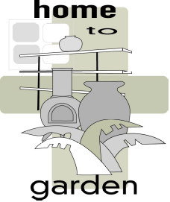
HOME TO GARDEN LTD

8A LOWER ROAD CHORLEYWOOD HERTS WD3 5LH
TEL/FAX: 00 44 1923 467372 MOB: 00 447980 893605
Email: home2gardenltd@yahoo.co.uk
Website: www.home2garden.co.uk

Displaying the Rainbow Bubbles

The most effective way to display the bubbles in by grouping them together in groups of three.

If there is a planted border near the front of the entrance they make a simple eye catching accent to the display. Ensure there is lots of light to reflect off the glass.

Alternatively, the glass bubbles can be displayed on their own in a raised bed. A minimalist theme is nice using slate pieces, rocks, and rockery plants to contrast with the glass.

The bubbles have also been used very effectively around a pond or water feature, nestled into the plants and flowers near the water.

Rainbow bubble hanging tea lights and glass stake tea lights look beautiful when lit up on both summer and winter nights. We supply shepherd staff hooks and s shaped hooks for the hanging tea lights. Always insure the soil is moist before inserting the glass stake tea lights into the ground or tub.

All Rainbow Bubble glass is frost proof and can remain outside throughout the year.

